**Install Selenium IDE and webdriver for Chrome**

**Install Google Chrome：**

* Download from <https://www.google.cn/chrome/> and install the latest Chrome browser.

**Install Selenium IDE for Chrome**

**Download CRX file to install Selenium IDE**

* Open Chrome's extension
* Drag the downloaded `.crx` file to the extension page to install Selenium IDE

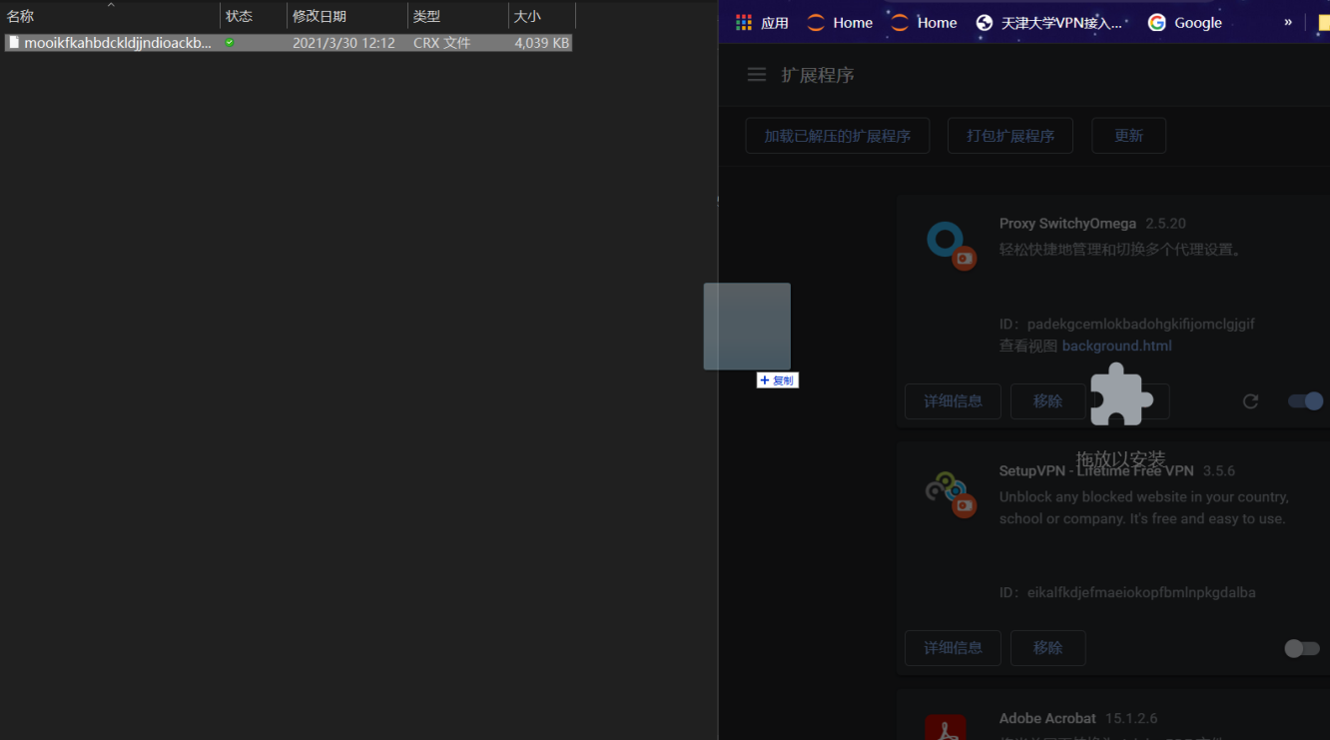

**Or you can install Selenium IDE from website：[website](https://www.selenium.dev/selenium-ide/)**

**Install webdriver for Chrome**

* You can download the webdriver corresponding to different versions of chrome on this [website.](https://chromedriver.chromium.org/downloads) You can check your chrome version at Chrome-Settings-About Chrome. Download the correct version of driver according to your chrome version.
* Copy webdriver to the root path of chrome. For example, C:\Program Files (x86)\Google\Chrome\Application

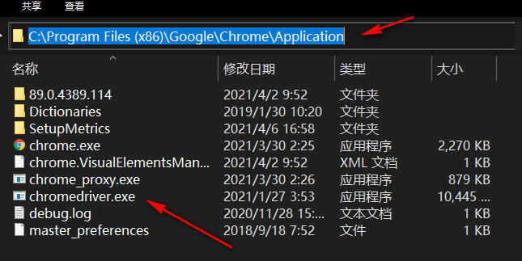

* Add the above path to the system path.

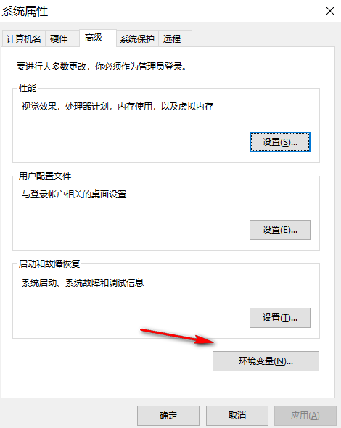

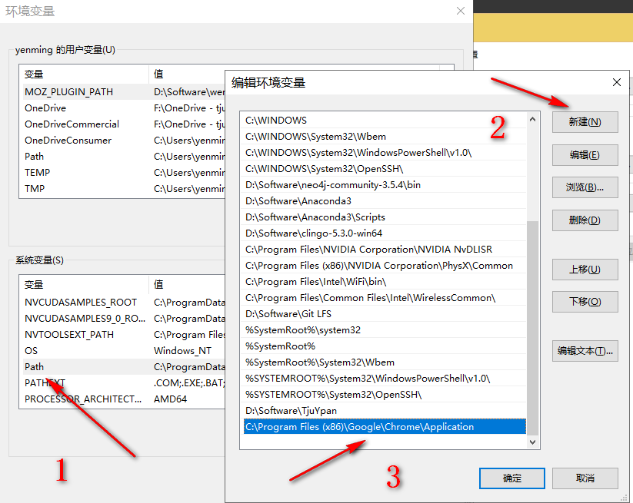

**Add JARs to Eclipse or IntelliJ IDEA**

* Add jars in folder ` ***selenium-junit-jar***` to Eclipse or IntelliJ IDEA